**PRIVACY PRESERVING ADVANCED ENCRYPTION STANDARD BASED ELECTRONIC HEALTH RECORD**

**A PROJECT REPORT**

*Submitted by*

**SARTHAK RAHIM [Reg No: RA1511008010341]**

**KISHORE BHATTER [Reg No: RA1511008010349]**

**SAKET BAJAJ [Reg No: RA1511008010357]**

**KSHAMA SHARMA [Reg No: RA1511008010253]**

*Under the Guidance of*

**Mr.K.MANIKANDAN**

(Asst.Professor, Department of Information Technology)

*In partial fulfillment of the Requirements for the Degree*

*of*

**BACHELOR OF TECHNOLOGY**

in

**INFORMATION TECHNOLOGY**

Of

**FACULTY OF ENGINEERING AND TECHNOLOGY**



SRM INSTITUTE OF SCIENCE AND TECHNOLOGY,KATTANKULATHUR-603203

**MAY 2019**

BONAFIDE CERTIFICATE

This is to certify that this project report titled “**PRIVACY PRESERVING ADVANCED ENCRYPTION STANDARD BASED ELECTRONIC HEALTH RECORD”** is the Bonafide work of **“SARTHAK RAHIM [Reg No: RA1511008010341], KISHORE BHATTER [Reg No: RA1511008010349], SAKET BAJAJ [Reg No: RA1511008010357], KSHAMA SHARMA [Reg No: RA1511008010253],** who carried out the project work under my supervision. Further certified, that to the best of my knowledge the work reported herein does not form part of any other thesis or dissertation on the basis of which a degree or award was conferred on any previous occasion for this or any other candidate.

**Mr. K. MANIKANDAN**  **Dr. G. VADIVU**

**GUIDE HEAD OF THE DEPARTMENT**

Assistant Professor Dept. of Information Technology

Dept. of Information Technology

Signature of Internal Examiner Signature of External Examiner

**ABSTRACT**

Cloud-based electronic health record (EHR) systems permit curative information to be transferred between hospitals; this is expected to contribute to improvisation of various healthcare services in the future. However, with increase in complications of the system architecture, the cloud based EMR systems allows for compromise of security features. The patients thus are under the risk of breach of security and leakage of confidential data.IN order to prevent this, methodologies like AES based access control to authorized entities have been proposed. However, most existing systems do not support AES based access control or considers extra privacy preserving cryptographic features. In this paper, we propose an AES based privacy preserving EHR model that performs attribute-based access control using Advanced Encryption Standard. Our EHR model, focused on security, performs partial encryption and uses electronic signatures when a patient document is sent to a document requester. We use AES encryption and decryption technique using 128 bit keys. Our proposed model works efficiently by sending only the necessary information to requesters who are authorized to treat the patient in question.

**ACKNOWLEDGEMENT**

We would like to express our deepest gratitude to our guide **Mr.K.MANIKANDAN** for his valuable guidance, consistent encouragement, personal caring, timely help and providing us an excellent atmosphere to complete the project and research work. All through the work, in spite of his busy schedule, he has extended cheerful and cordial support to me and my team for completing this research work and always resolved the conflicts in our timely meetings with him.

**Author**

|  |  |  |  |  |
| --- | --- | --- | --- | --- |
| CHAPTER NO. | | | **TABLE OF CONTENTS** | PAGE NO. |
|  | ABSTRACT | |  | iv |
|  | ACKNOWLEDGEMENT | |  | vi |
|  | LIST OF FIGURES | |  | vii |
|  | LIST OF SYMBOLS, ABBREVIATIONS | | | ix |
| 1. | INTRODUCTION | |  | 1 |
|  | 1.1 | GENERAL |  | 1 |
|  | 1.2 | OBJECTIVE | | 2 |
|  | 1.3 | EXISTING SYSTEM |  | 3 |
| 2 | LITERATURE STUDY | |  | 3 |
|  | 2.1 | INFORMATION PRIVACY CONCERN IN EHR | | 3 |
|  | 2.2 | CLOUD BASED EHR | | 3 |
|  | 2.3 | SECURE CLOUD BASED PHR | | 4 |
|  | 2.4 | CLOUD SERVICES ENHANCING HEALTHCARE | | 4 |
|  | 2.5 | PROPOSED SYSTEM | | 5 |
|  | 2.5.1 | ADVANTAGES | | 5 |
| 3 | REQUIREMENTS ENGINEERING | | | 5 |
|  | 3.1 GENERAL | | | 5 |
|  | 3.2 HARDWARE REQUIREMENTS | | | 6 |
|  | 3.3 SOFTWARE REQUIREMENTS | | | 6 |
| 4 | MODULES 10 | | | 7 |
|  | 4.1 GENERAL | | | 7 |
|  | 4.2 MODULE DESCRIPTION | | | 7 |
|  | 4.2.1 USER INTERFACE DSIGN | | | 7 |
|  | 4.2.2 PATIENT DETAILS TO DOCTOR | | | 8 |
|  | 4.2.3 ADMIN SENDS TO DOCTOR | | | 8 |
|  | 4.2.4 DOCTOR REPLY TO ADMIN | | | 8 |
|  | 4.2.5 ADMIN SENDS TO PATIENT | | | 8 |
|  | 4.2.6 VIEW MESSAGE DETAILS | | | 8 |
|  | 4.3 MODULE DIAGRAM | | | 9 |
| 5 | DESIGN ENGINEERING | | | 11 |
|  | 5.1 USE CASE DIAGRAM | | | 11 |
|  | 5.2 CLASS DIAGRAM | | | 12 |
|  | 5.3 OBJECT DIAGRAM | | | 13 |
|  | 5.4 STATE DIAGRAM | | | 14 |
|  | 5.5 ACTIVITY DIAGRAM | | | 15 |
|  | 5.6 SEQUENCE DIAGRAM | | | 16 |
|  | 5.7 DATA FLOW DIAGRAM | | | 17 |
|  | 5.8 COMPONENT DIAGRAM | | | 18 |
|  | 5.9 SYSTEM ARCHITECTURE | | | 19 |
| 6 | DEVELOPMENT TOOLS | | | 20 |
|  | 6.1 THE JAVA FRAMEWORK | | | 20 |
|  | 6.2 JAVA SERVER PAGES | | | 21 |
|  | 6.3 JAVA SERVLETS | | | 22 |
| 7 | RESULTS | | | 22 |
| 8 | CONCLUSION | | | 27 |
| 9 | FUTURE ENHANCEMENTS | | |  |
| 10 | APPENDIX | | | 28 |
| 11 | REFERENCES | | | 38 |
|  | PAPER PUBLICATION STATUS  PLAGIARISM REPORT | | |  |
|  |  |  | |  |

**LIST OF FIGURES**

4.1 UI Design……………………………………………………..8

4.2 Patient sends to Doctor……………………………………… 9

4.3 Admin Sends to Doctor …………………………………….. 9

4.4 Doctor Reply to Admin……………………………………... 10

4.5 Admin sends to patient……………………………………… 10

4.6 View Message details……………………………………….. 11

5.1 Use Case Diagram ……………………………………… …..12

5.2 Class Diagram ………………………………………………..13

5.3 Object Diagram………………………………………………..14

5.4 State Diagram ……………………………………… ………...15

5.5 Activity Diagram………………………………………………16

5.6 Sequence Diagram……………………………………………..17

5.7 Component Diagram…………………………………………...18

5.8 Data Flow Diagram………………………………………….....19

5.9 System Architecture………………………………………….....20

**LIST OF SYMBOLS**

|  |  |  |  |
| --- | --- | --- | --- |
| **S.NO** | **NOTATION**  **NAME** | **NOTATION** | **DESCRIPTION** |
| 1. | Class | *Class Name*  *-attribute*  *-attribute*  *+operation*  *+operation*  *+operation*  *+ public*  *-private*  *# protected* | Represents a collection of similar entities grouped together. |
| 2. | Association | name  Class B  Class A  Class A  Class B | Associations represents static relationships between classes. Roles represents the way the two classes see each other. |
| 3. | Actor | Class A  Class A  Class B  Class B | It aggregates several classes into a single classes. |
| 5. | Aggregation | Interaction between the system and external environment |

|  |  |  |  |
| --- | --- | --- | --- |
| 5. | Relation  (uses) | uses | Used for additional process communication. |
| 6. | Relation  (extends) | extends | Extends relationship is used when one use case is similar to another use case but does a bit more. |
| 7. | Communication |  | Communication between various use cases. |
| 8. | State | State | State of the process. |
| 9. | Initial State |  | Initial state of the object |
| 10. | Final state |  | Final state of the object |
| 11. | Control flow |  | Represents various control flow between the states. |
| 12. | Decision box |  | Represents decision making process from a constraint |
| 13. | Use case |  | Interaction between the system and external environment. |

|  |  |  |  |
| --- | --- | --- | --- |
| 14. | Component |  | Represents physical modules which is a collection of components. |
| 15. | Node |  | Represents physical modules which are a collection of components. |
| 16. | Data Process/State |  | A circle in DFD represents a state or process which has been triggered due to some event or action. |
| 17. | External entity |  | Represents external entities such as keyboard ,sensors,etc. |
| 18. | Transition |  | Represents communication that occurs between processes. |
| 19. | Object Lifeline |  | Represents the vertical dimensions that the object communications. |
| 20. | Message | Message | Represents the message exchanged. |

**LIST OF ABBREVATION**

|  |  |  |
| --- | --- | --- |
| **S.NO** | **ABBREVATION** | **EXPANSION** |
| 1**.** | DB | Database |
| 2. | JVM | Java Virtual Machine |
| 3. | JSP | Java Server Page |
| 4. | CB | Collective Behavior |
| 5. | AES | Advanced Encryption Standard |
| 6. | JRE | Java Runtime Environment |

**CHAPTER 1**

**INTRODUCTION**

The development of information technology has made great strides in the field of medical information. In order to manage large amounts of medical data transparently and cost- effectively, the need for computerized medical data has increased, and paper-based recording methods are gradually being replaced by digitized medical information systems . EHRs are electronically stored digital forms containing all of a patient's medical information. EHRs follow international standards to ensure interoperability so that patient data is not created and managed by a single health care organization, but by multiple medical institution systems that allow sharing between various health care providers and organizations(e.g., hospitals, laboratories, specialists, medical imaging facilities, pharmacies, emergency facilities, and universities). The adaption of EHR can play an important role in improving patient safety and health care quality. The existing EHR system was constructed in a centralized database environment and medical information was stored and managed in the context of hospital systems. However, this approach incurs high costs due to the initial construction of the system, maintenance, background knowledge, lack of skilled system engineers, and issues with patient medical information being incompatible with the systems in other hospitals. One potential solution for the aforementioned problems has begun inviting noteworthy attention. That solution is an EHR system based on the cloud environment. Cloud computing is managed by a cloud provider, which has advantages in terms of cost and system expansion when compared to existing systems. Patient data can also be shared and managed by various healthcare providers. However, an EHR system in the cloud environment comes with additional security issues compared to a single- system environment because patient data exchange occurs between the cloud platform and various healthcare institutions. Patient personal information may cause security and privacy problems because it contains sensitive and confidential data about the patient (e.g., health status information, provision of health care, payment for health care, identification of the patient). This information must be handled with care because its exposure would constitute a severe breach of the privacy of the individual. The EHR system must be designed to guarantee security and privacy when sharing personal patient information. Access control is very important for protecting patient privacy when providing health services. Access control means only transferring patient documents to authorized doctors. However, most recent access control systems for health services are inflexible due to using role-based access control (RBAC) schemes. Furthermore, additional security issues may arise due to a lack of consideration for various security factors. Therefore, in order to design a safe and lithe access control system to protect patient confidentiality, we propose an AES based access control model using extensible access control markup language.

**1.1 General**

Cloud storage is an emerging model of storage to provide scalable, elastic and pay-as-you-use service to cloud computing users. For individual usage, the subscribers enjoy the freedom to access to their data anywhere, anytime with any device. When cloud storage is utilized by a group of users, it allows team members to synchronize and manage all shared documents. Moreover, it also saves the user a lot of capital investment of expensive storage equipment. Also it enables the confidentiality, Integrity and availability under the CIA triad at all times.

**1.2 Objectives**

In this paper, we propose a cloud-based EHR model that performs AES-based access control using Advanced Encryption System Encryption and Decryption technique. Our AES based EHR model, focuses on security, and performs partial encryption when a patient document is sent to a document requester. We use AES encryption and decryption technology. Our proposed model works efficiently by sending only the essential information to requesters who are authorized to treat the patient in question workflows. Most current systems do not support fine-grained access control or take into account additional security factors such as encryption and Availability of information. In this project, we propose a privacy preserving attribute-based EHR model that performs encryption using the most secure Advanced Encryption Standard. Proposed EHR model, focuses on security, performs encryption and uses electronic signatures when a patient document is sent to a document requester. Moreover, it will also contain middle tier as the admin panel to provide smooth hassle free data transfers. The AES Encryption algorithm will use 128 bit key and 128 bit plaintext which will be faster to encrypt bigger files and more complex to be hacked into, also the rotation proposed for sensitive medical information is 12 rounds.

**1.3 Existing System**

Cloud-based electronic health record (EHR) systems permit curative information to be transferred between hospitals; this is expected to contribute to improvisation of various healthcare services in the future. However, with increase in complications of the system architecture, the cloud based EMR systems allows for compromise of security features. Cloud-based electronic health record (EHR) systems enable medical documents to be exchanged between medical institutions. Cloud-based EHR systems can introduce additional security threats when compared to existing singular systems.

DES Algorithm :-Data Encryption Standard Algorithm uses 64 bit plaintext and 64 bit key to encrypt with 16 rounds of rotation which is time consuming and more complex while encrypting and decrypting of data. The returned ciphertext is also 64 bit . With Modern Computing tools it is very easier to decode such information.

Hashing Algorithm- A hash algorithm is a function that converts a data string into a numeric string output of fixed length. The output string is generally very small as compared to the original data.

The Existing System uses Data Encryption Standard as the Cryptographic algorithm with 64 bit key for Encrypting data with 16 rounds of rotation to obtain the ciphertext. The encrypted data is stored in the database after hashing it from a predefined hash table which follows a predefined hash function. While the singular system enables a transfer of medical information between two nodes and which can only happen one to one and can be hacked if the physical computer is hacked , also preventing availability of information at all times. Existing System can be only accessed if both the systems are connected and if even one system is not in working condition then information cannot be accessed .

**1.4 Drawbacks of Existing System**

1. Hash collisions are practically unavoidable.
2. When hashing a random subset of a large set of possible keys.
3. Hash tables become quite inefficient when there are many collisions.
4. Waste of Space and need to buy large volume of data.
5. Existing System uses DES (Data Encryption standard) algorithm to ensure privacy of data. The DES uses 64 bit Plaintext and 64 bit Key which is rotated 16 times as per the standard to obtain the ciphertext.
6. With advancement and modern computing the 64-bit ciphertext can be decrypted easily and data can be breached.
7. Due to a lack of consideration for various security factors , additional security issue may arise .
8. Because of the instantaneous nature of electronic health records, they must be updated immediately after each patient visit — or whenever there is a change to the information. The failure to do so could mean other healthcare providers will rely on inaccurate data when determining appropriate treatment protocols.
9. Because of the instantaneous nature of electronic health records, they must be updated immediately after each patient visit — or whenever there is a change to the information. The failure to do so could mean other healthcare providers will rely on inaccurate data when determining appropriate treatment protocols.
10. The user can only sign documents on that particular computer.

**CHAPTER 2**

**LITERATURE STUDY**

**2.1 Information privacy concerns in EHR**

The concerns in healthcare services are needed to deal with privacy and data security risks in handling electronic healthcare records (EHR). With the restriction of the existing system dealing with number of aspects that affect data confidentiality concerns in EHR, the primary agenda of this study is to scrutinize the recent studies on data confidentiality concerns in EHR and then also to classify the related factors. A total of 199 articles were extracted using a predefined search string. A quality standard was applied on this set of articles, a total of 18 articles were identified for further analysis. Nine factors were found to influence data confidentiality concerns. However, the two major factors were information distribution and computer knowledge were commonly revealed as factors attributing to information privacy concerns in the healthcare domain. The unit of investigation was further inspected from two viewpoints; doctors and patients.

**2.2 A Cloud-based Approach for EHR**

We present a cloud-based method for the design of interoperable electronic healthcare record (EHR) systems. Cloud computing environments provides various benefits to the stakeholders in the healthcare ecosystem (patients, providers, payers, etc.). Dearth of data interoperability norms and solutions has been a major obstacle in the transfer of healthcare data between different participants. Our proposal CHISTAR accomplishes semantic interoperability by using a general design which uses a reference model that defines a general-purpose set of data structures and an prototype model that defines the clinical data attributes. CHISTAR application components are designed using the cloud component model approach that comprises of loosely coupled components that communicate asynchronously. In this paper we propose a high-level design for a system to achieve interoperability, data integration and security using CHISTAR.

**2.3 Secure Cloud Based PHR**

Acceptance of Electronic Health Record (EHR) applications has been slow due to consumers' concerns in security, confidentiality and faith, and the obstacles in interoperability and amalgamation with other Electronic Medical Record (EMR) systems. This paper proposes the design for a secure interoperable cloud-based PHR service. To augment the transferability and interoperability, we use the Continuity of Care Document (CCD) for both storage and transfer of EHR data for a particular patient. To provide security for each CCD object, we apply a wide variety of security mechanisms - including access control authorization, Advanced Encryption Standard AES, and digital signature - in an unified, entrenched, and fine manner, based on open standards such as Advanced Encryption Standard and Rijndael block cipher model. To support patient-controlled encryption and privacy-preserving keyword search, we use ciphertext-policy attribute-based encryption and public-key encryption with keyword search schemes, again in an integrated, embedded, and fine-grained manner.

**2.4 Cloud services - Enhancing healthcare sector**

The Malaysian hospital environment is predominantly device focused: whereby application services are typically installed manually on devices where the services are required. For an example, the software to review MRI images are only being made available to certain devices, typically located at the scanner itself. In order to enable integration of resources and sharing of data to deliver improved facilities to patients, the EHR is experiencing a changeover from a device-oriented architecture to a software as service based architecture (SaaS), this translates to the availability of application service on every device. Devices here can be categorized from smart phones to PDA's and workstations located both local and remotely. The medical devices are to be considered as a part of cloud to enable medical applications in a dynamic environment, where software functionalities are inevitably installed on request whenever necessary with the appropriate resources. In this paper, we will propose a system that will intertwine the various medical institutions and as of now, the level of access to patient data is different among medical institutions. Cloud computing will reduce the current gap and deliver a connected environment hence improving overall performance of operations.

**2.5 A Dynamic cloud computing platform for eHealth systems**

The proposed platform can be ran on the top of heterogeneous cloud computing systems that provides standard, dynamic and customizable services for eHealth systems. The proposed platform allows heterogeneous clouds provides a uniform service interface for eHealth systems that enable user to freely transfer their data and application from one vendor to another with minimal modifications. We implement the proposed platform for an eHealth system that maintains patients' data privacy in the cloud. We consider a data accessibility scenario with implementing two methods, AES and a light-weight data privacy method to protect patients' data privacy on the proposed platform. We asses the performance and the scalability of the implemented platform for a mass electronic medical record. The results show that the proposed platform has not introduced additional overheads when we run data privacy protection methods on the proposed platform.

**2.6 An Integrated Privacy Preserving Attribute Based Access Control Framework .**

Recent advances in IT have enabled many applications that generate huge amounts of personal data. Even though these advances have made many personalized applications such as personalized user-centric healthcare possible there is significant system maintenance cost related to data management, and security and privacy issues that need to be first addressed. Although cloud computing presents a new paradigm that helps maintaining users aggregated information distributed in different Internet enabled applications in one place, it also introduces new challenges in security and privacy. In this paper, we propose an integrated user-centric (or an organization-centric) privacy preserving attribute based access control approach to protect the security and privacy of a user's(or the organization's) data stored by a cloud service provider. The proposed approach includes a novel privacy preserving revocable ciphertext policy attribute-based encryption (PR-CP-ABE) scheme.

**2.7 Advantages of proposed system.**

1. An encrypting algorithm scrambles the message and it can only be unscrambled with a key created at the same time.
2. Cipher algorithms are either symmetric for encryption security.
3. 128 bit key is used.
4. Block data size is increased from 64-bit in existing system to 128-bit .
5. Private key is sent only to one customer .
6. Anomalies are reduced and better availability of data is ensured.
7. Confidentiality and integrity is taken into account.
8. Faster computational speed to encrypt data.
9. Encrypted data cannot be decrypted easily.

**CHAPTER 3**

**REQUIREMENTS ENGINEERING**

**3.1 General**

These are the requirements for doing the project. Without using these tools and software’s we can’t do the project. So we have two requirements to do the project. They are

1. Hardware Requirements.

2. Software Requirements.

**3.2 Hardware Requirements**

The hardware requirements serve as the fundamental for the implementation of the proposed architecture and should therefore be a mandatory specification of the host system. They are used by software engineers as the starting point for the system design. It shows what the system does and not how it should be implemented.

1. PROCESSOR : PENTIUM IV 2.6 GHz, Intel Core 2 Duo.
2. RAM : 4GB DD RAM
3. MONITOR : 15” COLOR
4. HARD DISK : 40 GB

**3.3 Software Requirements**

The software specification document is the requirement of the system. It should include both a description and a requirement of specification. It is a definition of the system’s job rather than the way in which the task is done. The software requirements provide a basis for creating the SRS document. It is useful in budgeting, holding scrum meetings, achieving goals and tracking the progress of the team regularly during the development cycle.

1. Front End : J2EE (JSP, SERVLETS) JAVASCRIPT
2. Back End : MY SQL 5.5
3. Operating System : Windows 07
4. IDE : Eclipse

**CHAPTER 4**

**MODULES**

**4.1 General**

In this project we have to secure the file is the main motivation. In this, there is two parts are there one is user side and another one is admin side. In user side, only they will upload the data in the form of file. After that in an admin side, there are four admins are there .If the first user wants the file they needs acknowledgements of the other three members then only they will use the file else they are not accepting the file .The main motive is that, if the first user wants the file the other three members acknowledgement is very important then only the requester will use the file.

There are six modules-:

1. User Interface Design
2. Patient details text to doctor
3. File Upload Module
4. Advanced Encryption Standard Module
5. Admin replies solution to patient
6. File Decrypt Module

**4.2 Module Description**

The functionalities performed in the different modules are as follows-:

**4.2.1 User Interface Design**

This is the first module of our project. The important role for the user is to move login window to user window. This module has created for the security purpose. In the user login page the user has to enter the credentials. It will check username and password is match or not (valid user id and valid password). If we enter any invalid username or password we can’t enter into login window to user window it will shows error message. So unauthorized user is prevented from accessing user information from login page after giving wrong credentials. It provides the first layer of security to the system. So the server containing user credentials also checks for the authentication of the user. It enhances the security and prevents unauthorized user from accessing the patient data. JSP is used to design the login page and authenticate the login user.

**4.2.2 Patient Details Text to Doctor**

This is the second module of our project. The important role for the patient is to upload the details about their disease to the admin.

**4.2.3 File Upload Module**

The file upload module consists of file being converted and encrypted and the value being stored in the database. The files that can be uploaded are of type docx, word and pdf formats. The uploaded prescription files need to be shared with the patient and the key for decryption is only shared with that patient.

**4.2.4 Advanced Encryption Standard Module**

AES is a ‘substitution–permutation network’. It comprises of a series of linked operations, which involves replacing inputs by specific outputs (substitutions) and others involve shuffling bits around (permutations). AES performs all its computations on bytes. Hence, AES treats the 128 bits of a plaintext block as 16 bytes. These 16 bytes are arranged in four columns and four rows for processing as a matrix −unlike DES, the number of rounds in AES is variable and depends on the length of the key. AES uses 128-bit keys, 192-bit keys and 256-bit keys for 10,12 and 14 rounds respectively . Each of these rounds uses a different 128-bit round sub-key, which is calculated from the original AES key.

**4.2.5 Admin Replies to Patient**

In this module the customer will also upload the file with the land longitude and the customer will set their key along with their file and if the file is different means it will validate and shows the output particular status of the land and details are stored in the particular data base.

**4.2.6 File Download and Decrypt Module**

The process of decryption of an AES ciphertext is similar to the encryption process in the reverse order. Each round consists of the four processes conducted in the reverse order .

Add round key

Mix columns

Shift rows

Byte substitution

**4.3 Module Diagrams**

Database

Welcome Page

Cloud App

Registration

Page

Login

Server

**Figure 4.1:** UI Design

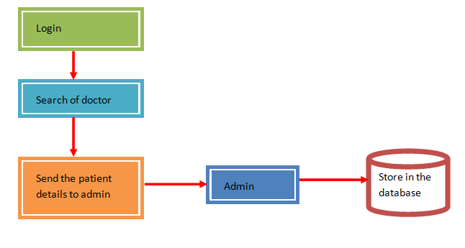

**Figure 4.2:** Patient sends to Doctor

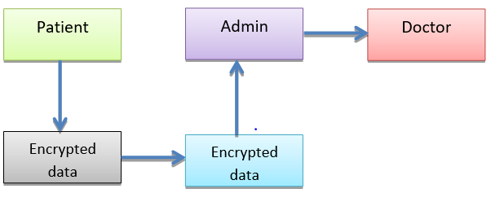

**Figure 4.3:** Admin Sends to Doctor

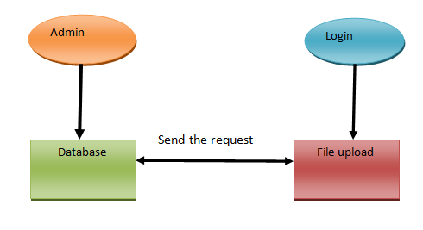

**Figure 4.4:** Doctor Reply to Admin

Patient

Doctor

Solutions to patient

Admin

Encrypted data

**Figure 4.5:** Admin Reply to Patient

**Patient**

**Doctor**

**Admin**

**PAGE**

**Database**

**Database**

**Messages**

**Figure 4.6:** View Message Details

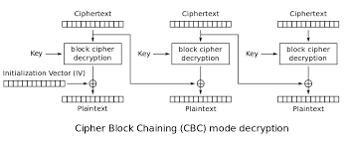

**Figure 4.7:** File Decrypt module

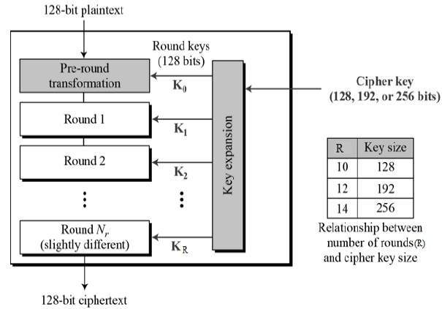

**Figure 4.8:** AES module

**CHAPTER 5**

**DESIGN ENGINEERING**

**5.1 Use Case Diagram**

The use case diagram is the main building block of [object oriented](http://en.wikipedia.org/wiki/Object_oriented) modeling. It is used both for general [conceptual modeling](http://en.wikipedia.org/wiki/Conceptual_model) of the systematic of the application, and for detailed modeling translating the models into code. For this in our component diagram first propose a data. In this proposed method we are using Cryptographic Algorithm to encrypt the data. Then user want to access the file by the permission of user and share the authenticated key.

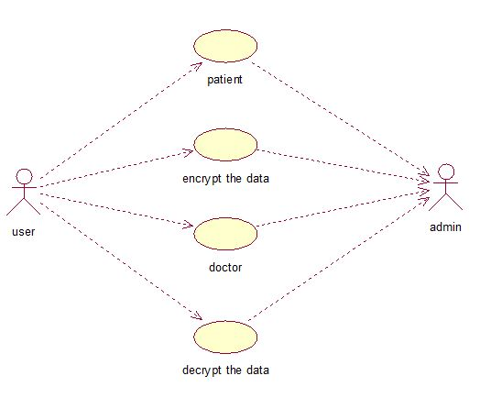

**Figure 5.1:** Use Case Diagram

**5.2 Class Diagram**

The class diagram is the fundamental block of object-oriented modeling. It is used both for general [conceptual modeling](http://en.wikipedia.org/wiki/Conceptual_model) of the system, and for detailed modeling and rendering the representations into [programming code](http://en.wikipedia.org/wiki/Programming_code). In class diagram first propose. For this in our component diagram first propose a data. In this proposed method we are using Cryptographic Algorithm to encrypt the data. Then user2 want to access the file by the permission of user1 share the authenticated key.

Doctor



Authentication



Register



Login()



Get information()



Patient



Authentication



Register



Login()



File upload



Get Service()

Admin



Username



Password



Login()



Update details()



Maintain details)

**Figure 5.2:** Class Diagram

**5.3 Object Diagram**

Object diagram dictates the flow of objects and how the process is running. In the above digram tells about the flow of objects between the classes.The main object of this diagram first propose a data expansion technique by creating sentiment reversed reviews. The original and reversed reviews are constructed in a one-to-one correspondence. Polarity shift is a dialectal phenomenon which can alter the sentiment polarity of the text. Negation is a polarity shift. The query from the user is searched in the database as per the conditions set and matched with the item. The resultant encrypted file is then shared to the requester as per the object diagram.

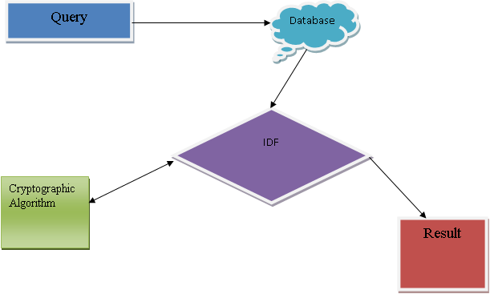

**Figure 5.3:** Object Diagram

**5.4 State Diagram**

State diagrams implies that the described architecture contains a finite number of states ; more often than not this is the case however there can be exceptions. State Diagrams are of different forms each differing in the semantics from one other. In our state diagram first propose a user. For this in our component diagram first propose a data. In this proposed method we are using Cryptographic Algorithm to encrypt the data. Then user2 want to access the file by the permission of user1 share the authenticated key.

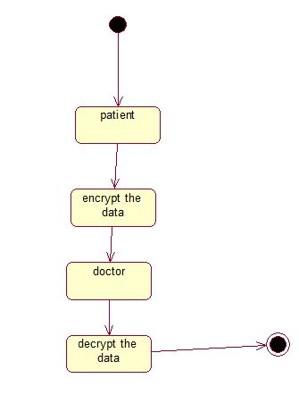

**Figure 5.4:** State Diagram

**5.5 Activity Diagram**

In the UML, activity diagrams can be used to describe the business functions and step-by-step workflows of modules in a system. An activity diagram describes the complete workflow of control. In our activity diagram first propose. For this in our component diagram first propose a data. In this proposed method we are using Cryptographic Algorithm to encrypt the data. Then user2 want to access the file by the permission of user1 share the authenticated key.

user

Login

File request

Admin request accept

Result

User access the file

**Figure 5.5:** Activity Diagram

**5.6 Sequence Diagram**

In our sequence diagram specifying processes operate with one another and in order. In our sequence diagram first propose a system. For this in our component diagram first propose a data In this proposed method we are using Cryptographic Algorithm to encrypt the data. Then user2 want to access the file by the permission of user1 share the authenticated key.

Patient

Doctor

Database

Admin

File Upload with encrypted key

Analysis file

Send to admin

Request file to Admin

Verify result

Decrypted key with solutions

Admin Send decrypted Key

If the Key Correct Means Access The file from database

**Figure 5.6:** Sequence Diagram

**5.7 Data Flow Diagram**

It does not show information about the sequence in which the processes will be executed. In the DFD the level zero process is the user authentication. For this in our component diagram first propose a data in this proposed method we are using cryptographic algorithm to encrypt the data. Then user2 want to access the file by the permission of user1 share the authenticated key.

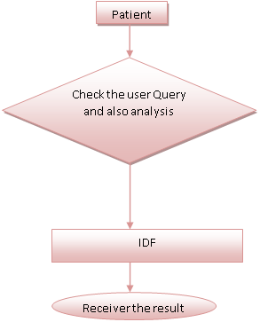

**Figure 5.7**: Data Flow Diagram

**5.8 Component Diagram**

In the UML, a component diagram describes how modules are twined together to form larger module and they are used to depict the structure of capriciously complex systems. For this in our component diagram first propose a data. In this proposed method we are using Cryptographic Algorithm to encrypt the data. Then user2 want to access the file by the permission of user1 share the authenticated key.

Patient

Login

File upload

Database

Decrypt the data

Encrypt the data

Result

**Figure 5.8:** Component Diagram

**5.9 System Architecture**

The systems architect establishes the basic structure of the system, we propose a Cryptographic Algorithm and we can put a small part of data in local machine and fog server in order to conserve the privacy. Moreover, on the basis of computational power, the algorithm can figure out the distribution quantity stored in cloud, server, and local machine, respectively. Through the hypothetical security investigation and investigational assessment, the viability of our system has been authenticated, which is really an influential addition to existing cloud storage scheme.

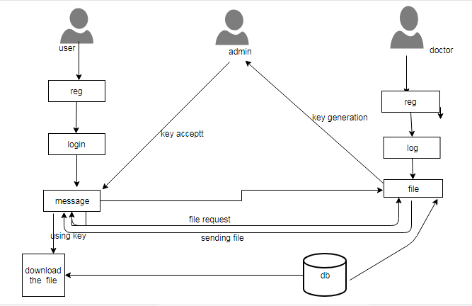

**Figure 5.9:** System Architecture

**CHAPTER 6**

**DEVELOPMENT TOOLS**

**6.1 The Java Framework**

In 1995 James Gosling released Java at Sun Microsystems . The language derives most of its [syntax](http://en.wikipedia.org/wiki/Syntax_(programming_languages)) from [C](http://en.wikipedia.org/wiki/C_(programming_language)) and [C++](http://en.wikipedia.org/wiki/C%2B%2B) but has a less complex [object model](http://en.wikipedia.org/wiki/Object_model) and lesser [low-level](http://en.wikipedia.org/wiki/Low-level_programming_language) facilities. Java uses Java Virtual Machine(JVM) to convert code into byte code thus making Java platform independent. Java is versatile, synchronized, class-based, and entity-oriented, and is precisely planned to have as few application dependences as possible. It is intended to let application developers run on any platform.

Java is considered by many as one of the most powerful programming languages of the 20th century, and is extensively used from software to web applications. The java framework is a new platform independent that simplifies application development internet. Java technology's versatility, efficiency, platform portability, and security make it the ideal technology for network computing.

**6.2 Java Server Pages**

JSP is used for creating and delivering dynamic web content. Database driven web apps are developed using JSP for server-side scripting. Developers directly insert java code in jsp files using JSP making maintenance easy.

JSP pages are efficient, it loads into the web servers memory  on receiving the request very first time and the subsequent calls are served within a very short period of time.

In today's environment most web sites servers dynamic pages based on user request. Database is very fitting way to store patient data. JDBC provide outstanding database connectivity in diverse database atmosphere. Using JSP and JDBC is very easy to develop database driven web application.

Java is known for its characteristic of "write once, run anywhere." JSP pages are platform independent Java Server Pages

Java Server Pages (JSP) technology is the Java platform technology for delivering lively material to web clients in a transportable, protected and precise way. The JavaServer Pages specification inherits the Java Servlet API to deliver web application developers with a vigorous framework for creating non static web content on the server using HTML, and XML templates, and Java code, which is safe, debauched, and not dependent on server platforms.

JSP has been developed based on the Servlet API and makes use of Servlet semantics. JSP handles the requests and responses. Although JSP technology is going to be a influential heir to elementary Servlets, they have an evolutionary affiliation and can be used in a supportive and corresponding manner.

**6.3 Java Servlets**

Java Servlet is a general server extension which means a java class can be dynamically loaded so as to swell the functionality of a server. Servlets are run on JVM and with web servers making it safe and portable.

Servlets do not require support for java on the web browser. Servlets do not use multiple processes to handle requests unlike CGI. Servlets can be handled by separate threads within the same process. Servlets are also portable and platform independent.

A web server is a computer with a specific program installed on it. Web server uses a web browser to interact with client. HTTP Protocols and web browsers are used to deliver content to clients.

The web servers is a package of  a number of software programs installed on a computer system connected to Internet for downloading the files on demand using [File Transfer](http://www.roseindia.net/servlets/IntroductionToWebServer.shtml) Protocol, serving e-mail and constructing and disseminating web pages. A web server is based on the client server model.

**CHAPTER 7**

**Screenshots**

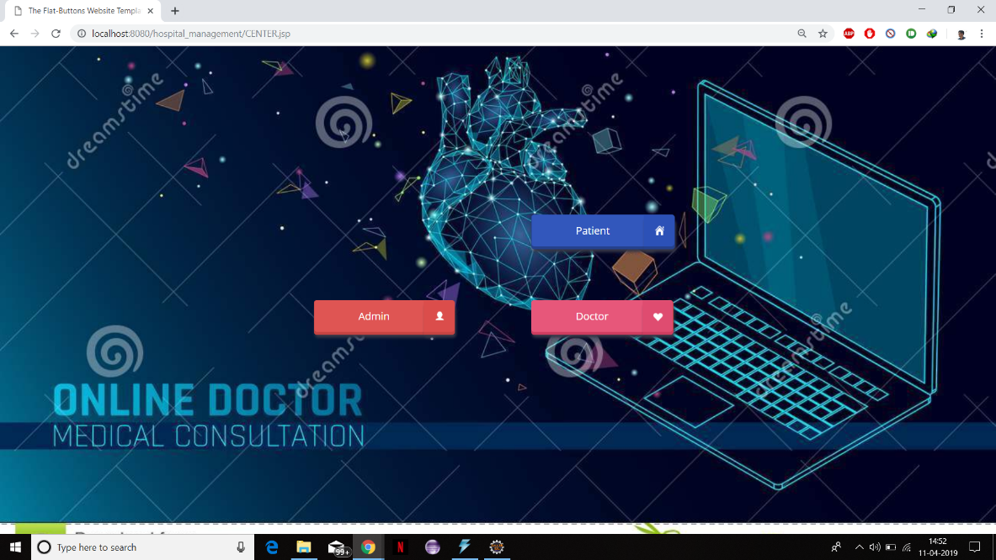

**Figure 7.1:** Center.jsp

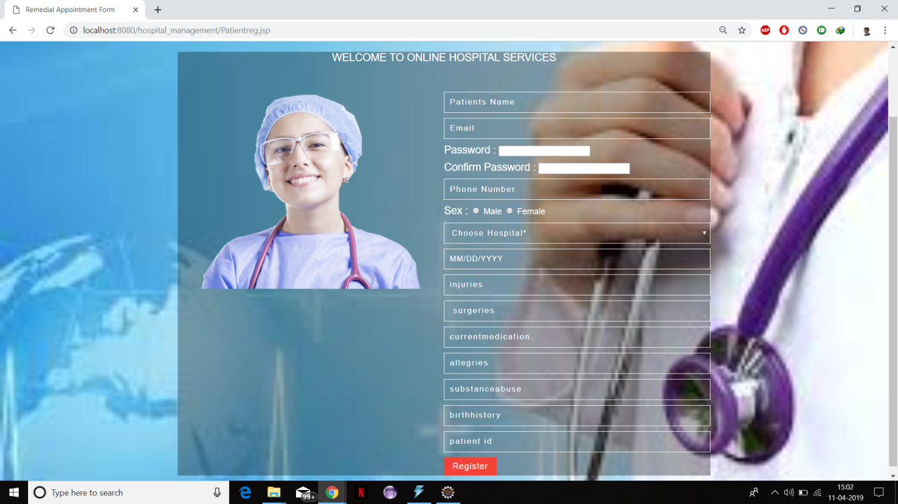

**Figure 7.2:** Patient Register

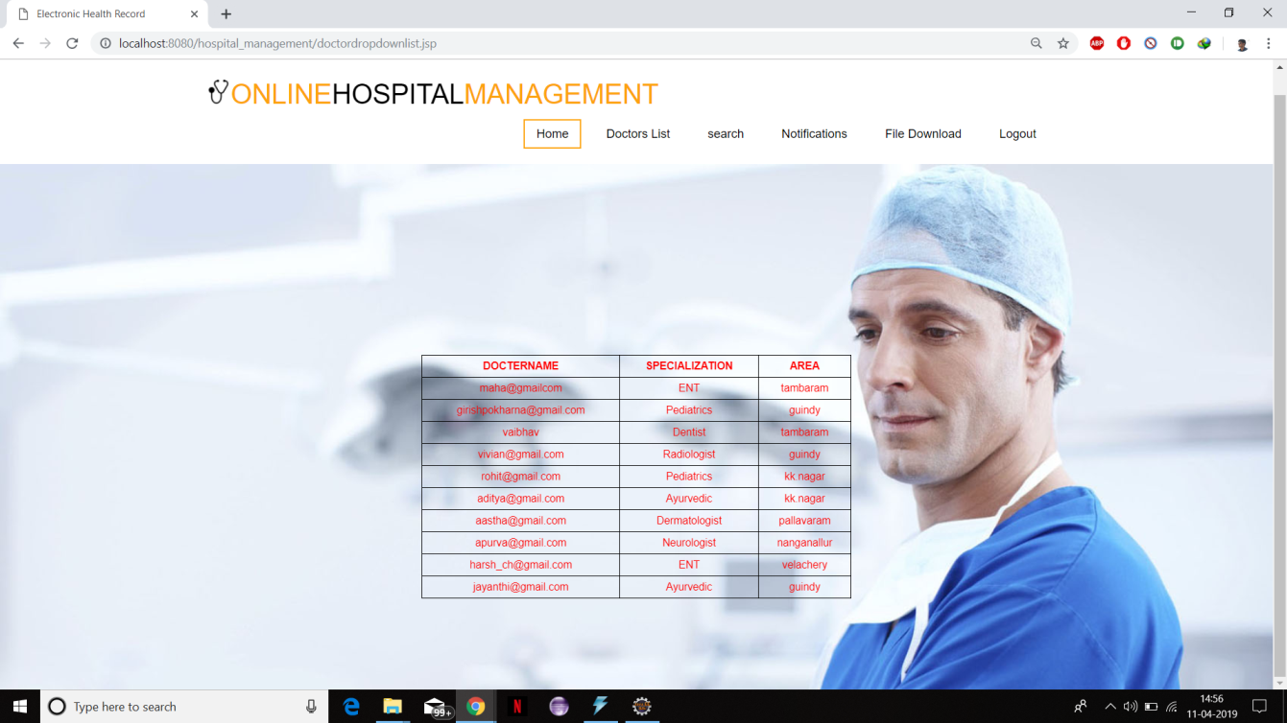

**Figure 7.3:** Doctors List

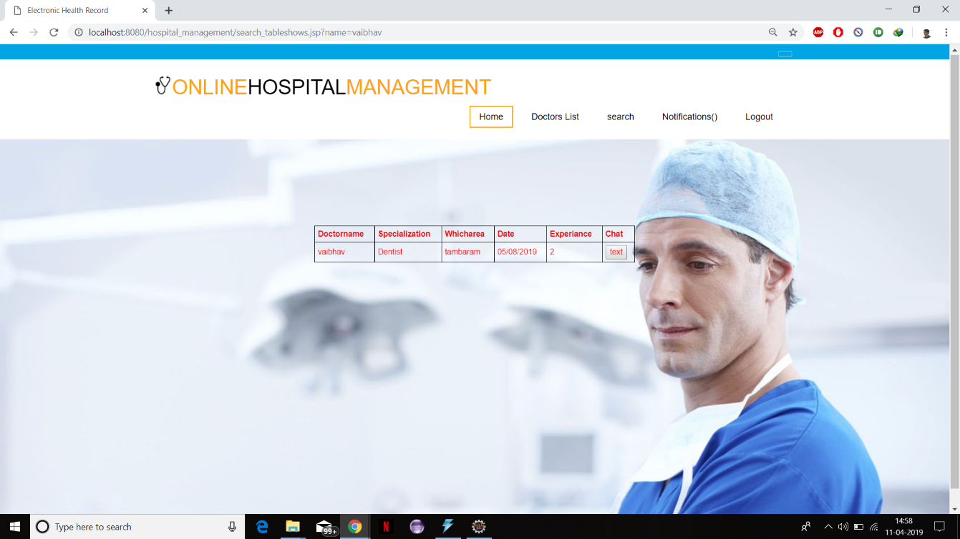

**Figure 7.4:** Doctor Chat

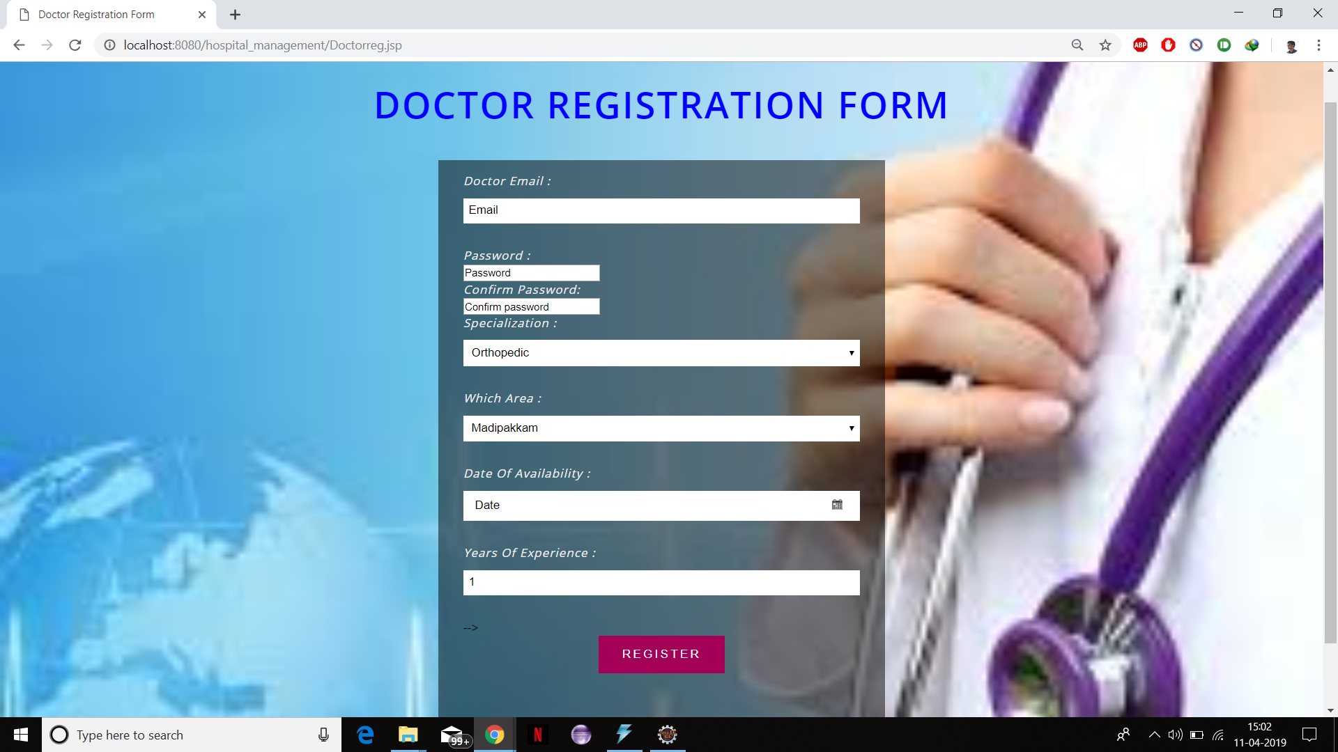

**Figure 7.5:** Doctor Registration

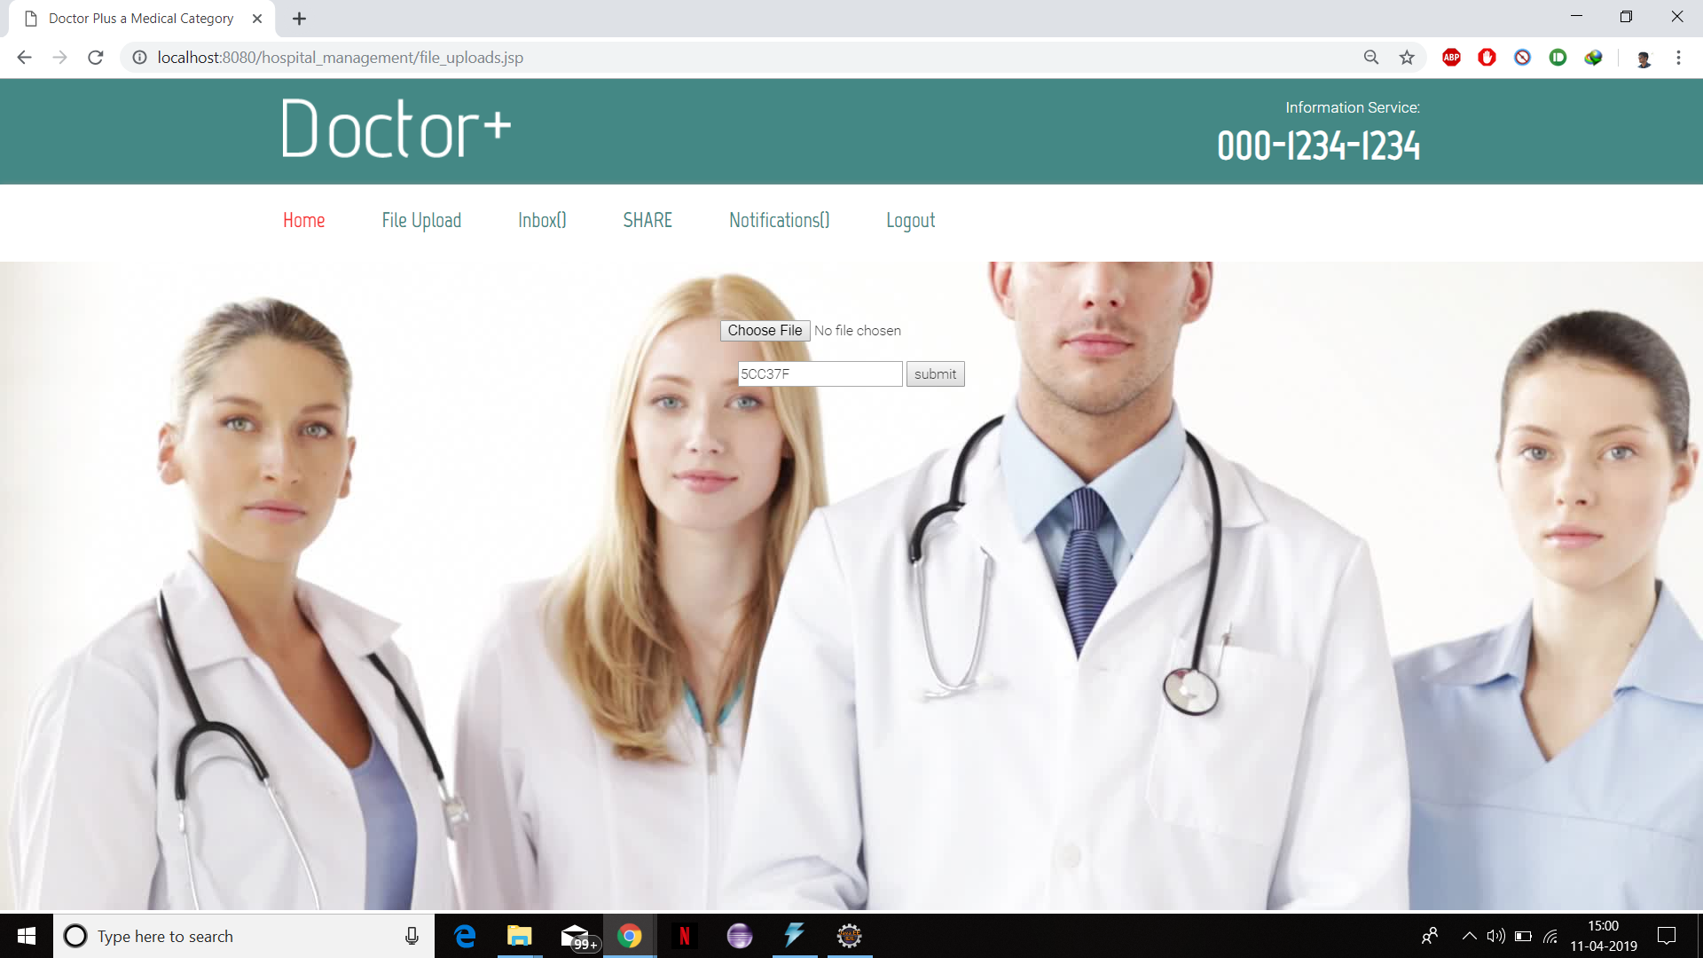

**Figure 7.6:** File Upload

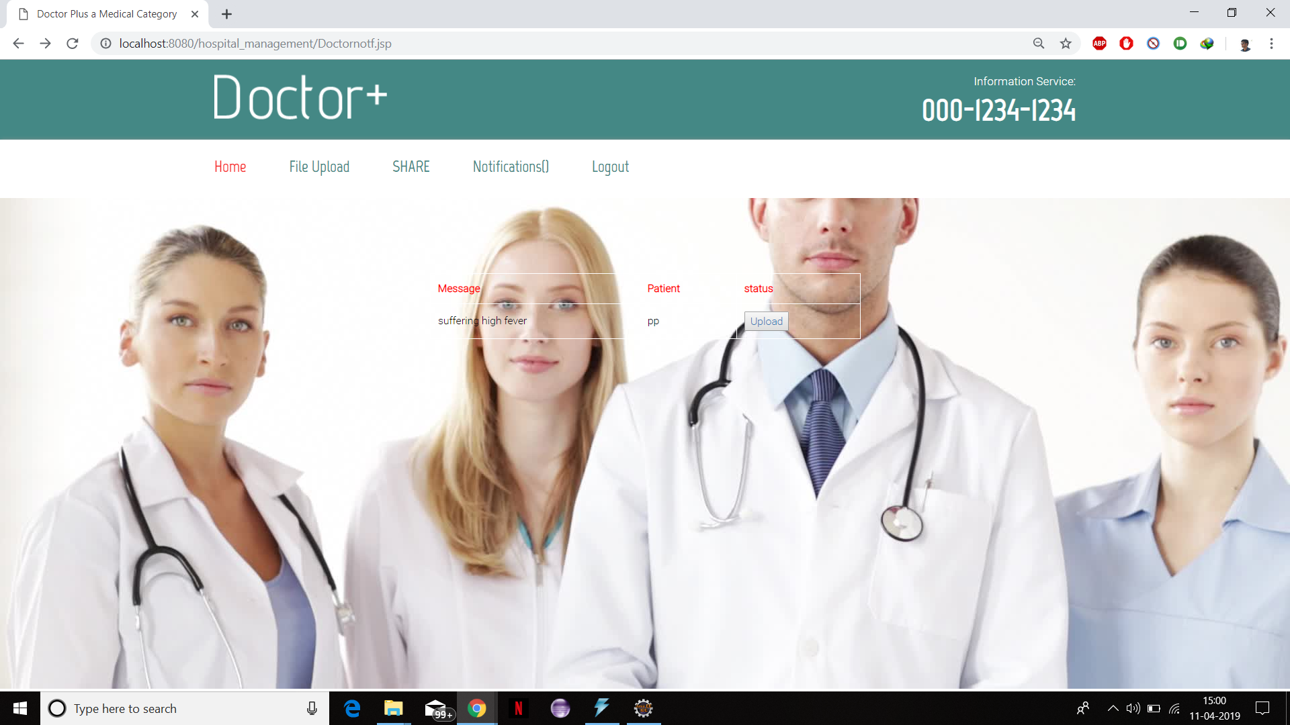

**Figure 7.7:** Doctor Notification

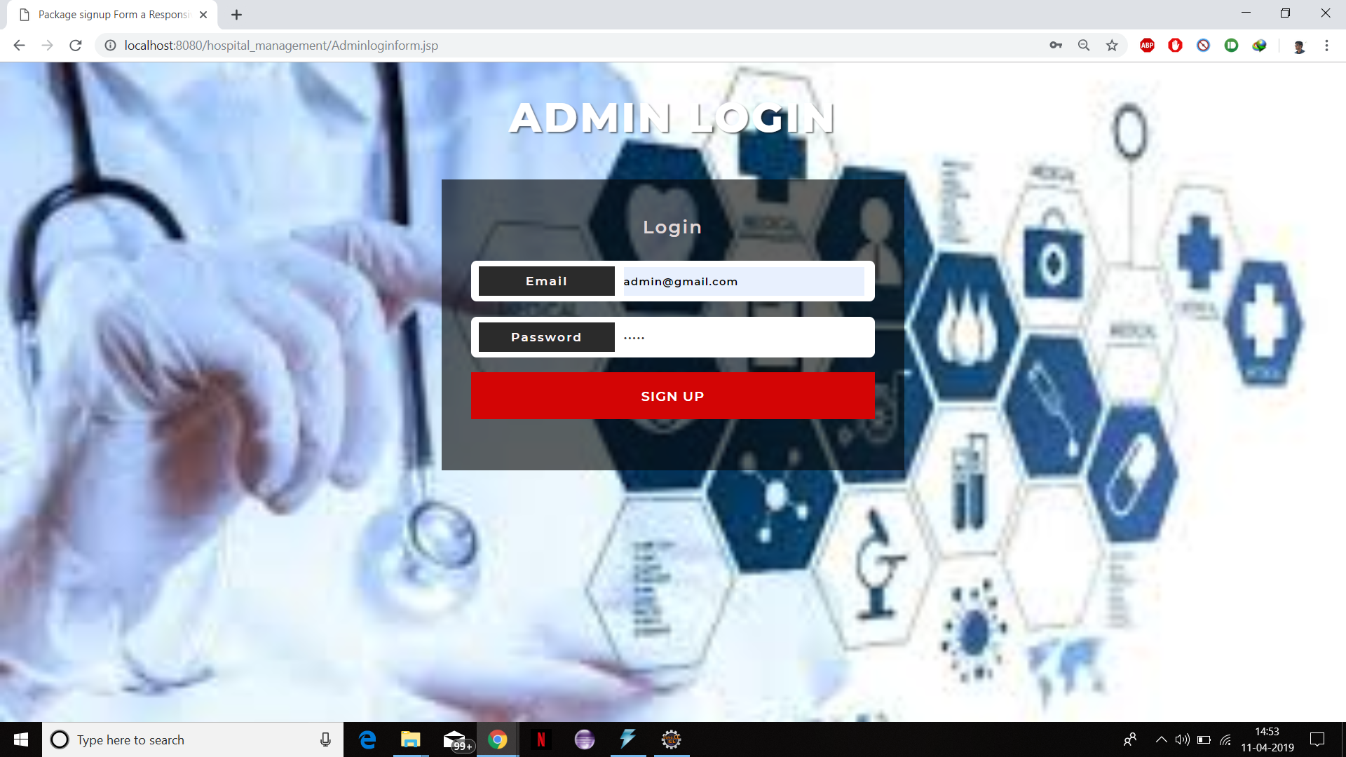

**Figure 7.8:** Admin Login

**CHAPTER 8**

**CONCLUSION**

Recently, EHR systems in the cloud environment have shown the potential to improve the quality of medical service by sharing and utilizing patient data across various medical institutions. However, this environment creates additional security risks and patient privacy can be violated by various malicious attacks. Despite the importance of data security, many systems do not consider security factors during their modeling process or regard them as minor factors. We proposed a cloud-based EHR model that guarantees patient privacy. The proposed model is divided into two stages: access control, and the application of encryption and digital signatures. The proposed model uses an ABAC method built upon XACML. After performing access control on patient documents, encryption is performed and digital signatures are added using XML digital signatures as an added security measure. The proposed model provides more flexible and fine-grained control than existing RBAC systems and alleviates the risk of exposing patient privacy information by using partial encryption and electronic signatures. The implementation of a prototype demonstrated the feasibility of the proposed model. We compared the implemented security factors with those used in other related studies and determined that the proposed method is superior to previous methods in terms of security.

**CHAPTER 9**

**FUTURE ENHANCEMENTS**

Future concept is more advanced than the proposed concept as the data owner and third party auditor need not be change the data at each time the file has been corrupted. Future enhancement provide delegation based data inspecting thus when the file on the cloud have been besmirched the proxy itself enhances security protocol to change the damaged file with original file present on the cloud. Similarly it provides multiple keywords to check the file stored in cloud. With Modern computing and fast Decoding Software the need to increase the Encryption Standards may arise. The future enhancement for this product must involve a secure storage on the cloud network with no access to the files directly but through only privacy preserving attribute based Advanced Encryption only. Moreover this product can be used to store, transmit, and communicate between individuals as well as Medical Institutions. The scope of this project is not just limited to encrypted communication between stakeholders but also to provide medical information in case of emergencies, surgeries or even in defence sector.

**CHAPTER 10**

**APPENDIX**

**10.1 AES.java**

package servlet;

import java.security.Key;

import javax.crypto.Cipher;

import javax.crypto.spec.SecretKeySpec;

import sun.misc.*;

public class AES

{

private static String algorithm = "AES";

private static byte[] keyValue=new byte[]

{ 'A', 'S', 'e', 'c', 'u', 'r', 'e', 'S', 'e', 'c', 'r', 'e', 't', 'K', 'e', 'y' };

// Performs Encryption

public static String encrypt99(String plainText) throws Exception

{

Key key = generateKey();

Cipher chiper = Cipher.getInstance(algorithm);

chiper.init(Cipher.ENCRYPT_MODE, key);

byte[] encVal = chiper.doFinal(plainText.getBytes())

String encryptedValue = new BASE64Encoder().encode(encVal);

return encryptedValue;

}

// Performs decryption

public static String crypt(String encryptedText) throws Exception

{

// generate key

//Cipher

Key key = generateKey();

Cipher chiper=Cipher.getInstance(algorithm);

chiper.init(Cipher.DECRYPT_MODE,key);

byte[] decordedValue = new BASE64Decoder().decodeBuffer(encryptedText);

byte[] decValue = chiper.doFinal(decordedValue);

String decryptedValue = new String(decValue);

return decryptedValue;

}

//generateKey() is used to generate a secret key for AES algorithm

public static Key generateKey() throws Exception

{

Key Key = new SecretKeySpec(keyValue, algorithm);

return Key;

}

// performs encryption & decryption

/* public static void main(String[] args) throws Exception

{

String plainText = "Password";

String encryptedText = AES.encrypt99(plainText);

String decryptedText = AES.decrypt(encryptedText);

System.out.println("Plain Text : " + plainText);

System.out.println("Encrypted Text : " + encryptedText);

System.out.println("Decrypted Text : " + decryptedText);

}*/

}

**10.2 ChatStore.java**

package servlet;

import impli.Regimple;

import inter.Reginter;

import java.io.IOException;

import javax.servlet.ServletException;

import javax.servlet.annotation.WebServlet;

import javax.servlet.http.HttpServlet;

import javax.servlet.http.HttpServletRequest;

import javax.servlet.http.HttpServletResponse;

import bean.Chat_store_bean;

@WebServlet("/ChatStore")

public class ChatStore extends HttpServlet {

private static final long serialVersionUID = 1L;

/**

* @see HttpServlet#HttpServlet()

*/

public ChatStore() {

super();

// TODO Auto-generated constructor stub

}

/**

* @see HttpServlet#doGet(HttpServletRequest request, HttpServletResponse response)

*/

protected void doGet(HttpServletRequest request, HttpServletResponse response) throws ServletException, IOException {

// TODO Auto-generated method stub

}

/**

* @see HttpServlet#doPost(HttpServletRequest request, HttpServletResponse response)

*/

protected void doPost(HttpServletRequest request, HttpServletResponse response) throws ServletException, IOException {

String name=request.getParameter("Receiver");

String mes=request.getParameter("message");

System.out.println("nameeeeeeeeee"+name);

System.out.println("mmmmmmmmmmmmmeeesssssssssssss"+mes);

Chat_store_bean cb=new Chat_store_bean();

cb.setName(name);

cb.setMessage(mes);

Reginter ri=new Regimple();

int k=ri.chatstorage(cb);

if(k==1){

response.sendRedirect("successs.jsp");

}

else{

response.sendRedirect("error.jsp");

}

**10.3 Download.java**

package servlet;

import impli.Regimple;

import inter.Reginter;

import java.io.IOException;

import java.io.PrintWriter;

import javax.servlet.ServletException;

import javax.servlet.annotation.WebServlet;

import javax.servlet.http.HttpServlet;

import javax.servlet.http.HttpServletRequest;

import javax.servlet.http.HttpServletResponse;

import javax.swing.JDialog;

import javax.swing.JOptionPane;

@WebServlet("/Download")

public class Download extends HttpServlet {

private static final long serialVersionUID = 1L;

/**

* @see HttpServlet#HttpServlet()

*/

public Download() {

super();

// TODO Auto-generated constructor stub

}

protected void doGet(HttpServletRequest request, HttpServletResponse response) throws ServletException, IOException {

doPost(request, response);

protected void doPost(HttpServletRequest request, HttpServletResponse response) throws ServletException, IOException {

System.out.println("Welcome download page");

String filename=request.getParameter("filename");

System.out.println("filename---"+filename);

String filekey=request.getParameter("key");

System.out.println("Filekey-----:"+filekey);

Reginter i1=new Regimple();

String filekey1=i1.getpublickey(filename);

System.out.println(filekey1);

JOptionPane jpane=new JOptionPane("Enter secret Key");

JDialog jdialogue=jpane.createDialog("Alert");

jdialogue.setAlwaysOnTop(true);

jdialogue.show();

String typingPrivatekey=JOptionPane.showInputDialog("Enter your Secret Key");

if(filekey1.equalsIgnoreCase(typingPrivatekey)) {

System.out.println("matched");

PrintWriter out=null;

try

{

out=response.getWriter();

String filepath="D:\\Workspace\\hospitalmanagement\\WebContent\\Local\\";

response.setContentType("APPLICATION/OCTET-STREAM"

response.setHeader("Content-Disposition","attachment; filename=\"" + filename + "\"");

java.io.FileInputStream fileInputStream=new java.io.FileInputStream(filepath+filename); int i;

while ((i=fileInputStream.read()) != -1) {

out.write(i);

}

fileInputStream.close();

}

catch (Exception e)

{

e.printStackTrace();

}

}

else{

System.out.println("Failed");

JOptionPane.showMessageDialog(null,"Sorry Your Key is Wrong")

response.sendRedirect("Error.jsp");

}

**10.4 Share.java**

package servlet;

import impli.Regimple;

import inter.Reginter;

import java.io.IOException;

import javax.servlet.ServletException;

import javax.servlet.annotation.WebServlet;

import javax.servlet.http.HttpServlet;

import javax.servlet.http.HttpServletRequest;

import javax.servlet.http.HttpServletResponse;

import bean.Sharebean;

@WebServlet("/Share")

public class Share extends HttpServlet {

private static final long serialVersionUID = 1L;

/**

* @see HttpServlet#HttpServlet()

*/

public Share() {

super();

// TODO Auto-generated constructor stub

}

/**

* @see HttpServlet#doGet(HttpServletRequest request, HttpServletResponse response)

*/

protected void doGet(HttpServletRequest request, HttpServletResponse response) throws ServletException, IOException {

doPost(request, response);

}

/**

* @see HttpServlet#doPost(HttpServletRequest request, HttpServletResponse response)

*/

protected void doPost(HttpServletRequest request, HttpServletResponse response) throws ServletException, IOException {

String file=request.getParameter("file");

System.out.println("file"+file);

String size=request.getParameter("size");

System.out.println("size"+size);

String encrypt=request.getParameter("encrypt");

System.out.println("encrypt"+encrypt);

Sharebean sbb=new Sharebean();

sbb.setFile(file);

sbb.setSize(size);

sbb.setEncrypt(encrypt);

Reginter u=new Regimple();

int i=u.sharepage(sbb);

if(i==1)

{

response.sendRedirect("File_upload.jsp");

}

else

{

response.sendRedirect("error.jsp");

}

}

}

**10.5 Patientreg.java**

package servlet;

import impli.Regimple;

import inter.Reginter;

import java.io.IOException;

import javax.servlet.ServletException;

import javax.servlet.annotation.WebServlet;

import javax.servlet.http.HttpServlet;

import javax.servlet.http.HttpServletRequest;

import javax.servlet.http.HttpServletResponse;

import javax.servlet.http.HttpSession;

import bean.Patientlogbean;

@WebServlet("/Patientlogin")

public class Patientlogin extends HttpServlet {

private static final long serialVersionUID = 1L;

/**

* @see HttpServlet#HttpServlet()

*/

public Patientlogin() {

super();

// TODO Auto-generated constructor stub

}

/**

* @see HttpServlet#doGet(HttpServletRequest request, HttpServletResponse response)

*/

protected void doGet(HttpServletRequest request, HttpServletResponse response) throws ServletException, IOException {

// TODO Auto-generated method stub

}

/**

* @see HttpServlet#doPost(HttpServletRequest request, HttpServletResponse response)

*/

protected void doPost(HttpServletRequest request, HttpServletResponse response) throws ServletException, IOException {

String name=request.getParameter("patientid");

HttpSession ses = request.getSession(true);

ses.setAttribute("user", name);

System.out.println("patientid"+name);

String pswd=request.getParameter("password");

System.out.println("password"+pswd);

Patientlogbean pr=new Patientlogbean();

pr.setYourname(name);

pr.setPassword(pswd);

Reginter jj=new Regimple();

boolean j=jj.Patientlog(pr);

if(j==true){

response.sendRedirect("patientmain.jsp");

}

else{

response.sendRedirect("error");

}

}

}

**10.6 Encrypt.java**

package servlet;

import java.security.Key;

import javax.crypto.Cipher;

import sun.misc.BASE64Decoder;

import sun.misc.BASE64Encoder;

public class Encrypt {

public static String encrypt(String Data) throws Exception

{

System.out.println("Encrypted in coming");

Key key = Publickey.generateKey();

Cipher c = Cipher.getInstance("AES");

c.init(Cipher.ENCRYPT_MODE, key);

byte[] encVal = c.doFinal(Data.getBytes());

String encryptedValue = new BASE64Encoder().encode(encVal);

return encryptedValue;

}

public static String decrypt(String encryptedData) throws Exception

{

Key key = Publickey.generateKey();

Cipher c = Cipher.getInstance("AES");

c.init(Cipher.DECRYPT_MODE, key);

byte[] decordedValue = new BASE64Decoder().decodeBuffer(encryptedData);

byte[] decValue = c.doFinal(decordedValue);

String decryptedValue = new String(decValue);

//System.out.println("key is :::"+ABEKey.generateKey());

return decryptedValue;

}

}

**10.7 Publickey.java**

package servlet;

import java.security.Key;

import javax.crypto.spec.SecretKeySpec;

public class Publickey {

private static final String ALGO = "AES";

private static final byte[] keyValue =

new byte[] { 'T', 'h', 'e', 'B', 'e', 's', 't','S', 'e', 'c', 'r','e', 't','k','e','y'};

public static Key generateKey() throws Exception

{

Key key = new SecretKeySpec(keyValue, ALGO);

return key:

}

}

**10.8 Search_name_servlet.java**

package servlet;

import java.io.IOException;

import javax.servlet.ServletException;

import javax.servlet.annotation.WebServlet;

import javax.servlet.http.HttpServlet;

import javax.servlet.http.HttpServletRequest;

import javax.servlet.http.HttpServletResponse;

import javax.servlet.http.HttpSession;

/**

* Servlet implementation class Search_name_servlet

*/

@WebServlet("/Search_name_servlet")

public class Search_name_servlet extends HttpServlet {

private static final long serialVersionUID = 1L;

/**

* @see HttpServlet#HttpServlet()

*/

public Search_name_servlet() {

super();

// TODO Auto-generated constructor stub

}

/**

* @see HttpServlet#doGet(HttpServletRequest request, HttpServletResponse response)

*/

protected void doGet(HttpServletRequest request, HttpServletResponse response) throws ServletException, IOException {

doPost(request,response); }

protected void doPost(HttpServletRequest request, HttpServletResponse response) throws ServletException, IOException {

String name=request.getParameter("search");

System.out.println(name);

HttpSession hs=request.getSession();

hs.setAttribute("s", name);

if(name.equals(null)){

response.sendRedirect("error.jsp");

}

else{

response.sendRedirect("chats.jsp");

}

}

}

**10.9 Reginter.java**

package inter;

import bean.Adminbean;

import bean.Chat_store_bean;

import bean.Filebean;

import bean.Logbean;

import bean.Patientlogbean;

import bean.Patientregbean;

import bean.Regbean;

import bean.Requestbean;

import bean.Searchbean;

import bean.Sharebean;

public interface Reginter {

public int regist(Regbean bb);

public boolean log(Logbean ll);

public int patientregister(Patientregbean prb);

public boolean Patientlog(Patientlogbean pr);

public boolean doctorsearch(Searchbean sb);

public int chatstorage(Chat_store_bean cb);

public int fileup(Filebean b);

public int sharepage(Sharebean sbb);

public int Request(Requestbean rbb);

public int adminpage(Adminbean abb);

public String getpublickey(String filename);

}

**10.10 FileUpload.java**

package servlet;

import impli.Regimple;

import inter.Reginter;

import java.io.BufferedWriter;

import java.io.File;

import java.io.FileInputStream;

import java.io.FileOutputStream;

import java.io.FileWriter;

import java.io.IOException;

import java.util.ArrayList;

import javax.servlet.ServletException;

import javax.servlet.annotation.WebServlet;

import javax.servlet.http.HttpServlet;

import javax.servlet.http.HttpServletRequest;

import javax.servlet.http.HttpServletResponse;

import org.apache.poi.hwpf.HWPFDocument;

import org.apache.poi.hwpf.extractor.WordExtractor;

import bean.Filebean;

import com.itextpdf.text.Chunk;

import com.itextpdf.text.Document;

import com.itextpdf.text.Element;

import com.itextpdf.text.Font;

import com.itextpdf.text.PageSize;

import com.itextpdf.text.Paragraph;

import com.itextpdf.text.pdf.PdfReader;

import com.itextpdf.text.pdf.PdfWriter;

import com.itextpdf.text.pdf.parser.PdfTextExtractor;

import com.oreilly.servlet.multipart.FilePart;

import com.oreilly.servlet.multipart.MultipartParser;

import com.oreilly.servlet.multipart.ParamPart;

import com.oreilly.servlet.multipart.Part;

/**

* Servlet implementation class Fileupload

*/

@WebServlet("/Fileupload")

public class Fileupload extends HttpServlet {

private static final long serialVersionUID = 1L;

/**

* @see HttpServlet#HttpServlet()

*/

public Fileupload() {

super();

// TODO Auto-generated constructor stub

}

/**

* @see HttpServlet#doGet(HttpServletRequest request, HttpServletResponse response)

*/

protected void doGet(HttpServletRequest request, HttpServletResponse response) throws ServletException, IOException {

// TODO Auto-generated method stub

}

/**

* @see HttpServlet#doPost(HttpServletRequest request, HttpServletResponse response)

*/

protected void doPost(HttpServletRequest request, HttpServletResponse response) throws ServletException, IOException {

System.out.println("fileupload");

MultipartParser mp =new MultipartParser(request, 999999999);

Part part = null;

ArrayList paramValues = new ArrayList();

FilePart filepart = null;

ParamPart param=null;

File file1 = null;

String filepath1 = null;

String filetype=null;

String filepath2 = null;

String filename = null;

long size=0;

String path=getServletContext().getRealPath("");

System.out.println("path0000000000000000000000=="+path);

String editpath=path.substring(0, path.indexOf("."));

System.out.println("edithpath1111111111111111======"+editpath);

String fullpath=editpath+"hospitalmanagement\\WebContent\\local\\";

System.out.println("fullpath333333333333333=="+fullpath);

while((part=mp.readNextPart())!=null){

if(part.isFile()){

filepart=(FilePart)part;

filename=filepart.getFileName();

System.out.println("filename9999999999999999=="+filename);

fullpath=fullpath+filename;

System.out.println("fullpath5555555555555555555=="+fullpath);

File file=new File(fullpath);

size=filepart.writeTo(file);

System.out.println("size6666666666666=="+size);

filetype=filepart.getContentType();

System.out.println("filetype88888888888---"+filetype);

}

else if(part.isParam()){

param = (ParamPart) part;

String tagName =param.getName();

System.out.println("tagName ============= " + tagName);

String tagValue = param.getStringValue();

System.out.println("tagValue ************ " + tagValue);

paramValues.add(tagValue);

paramValues.add(tagName);

}

}

// FileInputStrean get bytes from file

String filecontent = "";

String encrpt = null;

String encontent = null;

if (filename.endsWith(".txt")) {// if open

//file encrypted and store into filepath1

FileInputStream fis = new FileInputStream(fullpath);

byte[] b = new byte[fis.available()];

fis.read(b);

String reading = new String(b);

filecontent = filecontent + reading;

System.out.println("filecontent=" + filecontent);

try {//try1 open

encontent = AES.encrypt99(filecontent);

System.out.println("encontent===="+encontent);

filepath1 = editpath + "\\hospital management\\WebContent\\Encrypt\\"+filename;

file1 = new File(filepath1);

file1.createNewFile();

if (!file1.exists()) {file1.createNewFile();}// If file doesn't exists, then create it

FileWriter fw = new FileWriter(file1.getAbsoluteFile());

BufferedWriter bw = new BufferedWriter(fw);

bw.write(encontent);// Write in file

bw.close();// Close connection

System.out.println("fileeeeeeeeeeeeeeeee" + filepath1);

//file decrypted and store into filepath2

String decontent= AES.crypt(encontent);

System.out.println("decontent===="+decontent);

filepath2 = editpath + "\\hospital management\\WebContent\\Decrypt\\"+filename;

File file2 = new File(filepath2);

file2.createNewFile();

if (!file1.exists()) {file1.createNewFile();}// If file doesn't exists, then create it

FileWriter fw1 = new FileWriter(file2.getAbsoluteFile());

BufferedWriter bw1 = new BufferedWriter(fw1);

bw1.write(decontent);// Write in file

bw1.close();// Close connection

System.out.println("fileeeeeeeeeeeeeeeee" + filepath2);

} catch (Exception e) {

e.printStackTrace();}

}

else if (filename.endsWith(".docx"))

{

WordExtractor extractor = null;

FileInputStream fis2=new FileInputStream(fullpath);

System.out.println("file is"+fis2);

HWPFDocument document=new HWPFDocument(fis2);

extractor = new WordExtractor(document);

String [] fileData = extractor.getParagraphText();

String mydate=extractor.getTextFromPieces();

System.out.println("DATASSSSSSSSSSSSSSSSSss "+fileData);

System.out.println("THE MYYYYYYYYYYY "+mydate);

String text1=null;

System.out.println("filedata len "+fileData.length);

}

else if(filename.endsWith(".pdf")) {

//System.out.println("padf file name"+file1.getName());

PdfReader pdfReader=new PdfReader(fullpath);

String Text7 = null;

int pages=pdfReader.getNumberOfPages();

for(int i1=1;i1<pages;i1++){

filecontent=PdfTextExtractor.getTextFromPage(pdfReader, i1);

System.out.println("page:"+i1+" "+filecontent);

Text7=Text7+filecontent;

}

System.out.println("Pdf full content ="+Text7);

try {

encrpt = Encrypt.encrypt(filecontent);

Document document=new Document(PageSize.A4);

/* File file=new File("C:\\Users\\spiro13\\Desktop\\naga\\"+pdffilename);

System.out.println(file.delete());*/

PdfWriter.getInstance(document, new FileOutputStream(new File(filepath2+filename)));

//FileOutputStream fileOutputStream=new FileOutputStream("C:\\Users\\spiro13\\Desktop\\naga\\pdffilename1.pdf");

Chunk chunk=new Chunk(encrpt);

document.open();

Font font=new Font();

font.setStyle(Font.BOLD);

Paragraph p1=new Paragraph(chunk);

p1.setAlignment(Element.ALIGN_LEFT);

document.add(p1);

document.close();

System.out.println("pdf writing is completed");

//fileOutputStream.write(encrpt.getBytes());

System.out.println(encrpt);

} catch(Exception e){

e.printStackTrace();

}

try {

encontent = AES.encrypt99(filecontent);

System.out.println("encontent===="+encontent);

filepath1 = editpath + "\\hospitalmanagement\\WebContent\\Encrypt\\"+filename;

file1 = new File(filepath1);

file1.createNewFile();

if (!file1.exists()) {file1.createNewFile();}// If file doesn't exists, then create it

FileWriter fw = new FileWriter(file1.getAbsoluteFile());

BufferedWriter bw = new BufferedWriter(fw);

bw.write(encontent);// Write in file

bw.close();// Close connection

System.out.println("fileeeeeeeeeeeeeeeee" + filepath1);

//file decrypted and store into filepath2

String decontent= AES.crypt(encontent);

System.out.println("decontent===="+decontent);

filepath2 = editpath + "\\hospitalmanagement\\WebContent\\Decrypt\\"+filename;

File file2 = new File(filepath2);

file2.createNewFile();

if (!file1.exists()) {file1.createNewFile();}// If file doesn't exists, then create it

FileWriter fw1 = new FileWriter(file2.getAbsoluteFile());

BufferedWriter bw1 = new BufferedWriter(fw1);

bw1.write(decontent);// Write in file

bw1.close();// Close connection

System.out.println("fileeeeeeeeeeeeeeeee" + filepath2);

}// try close

catch (Exception e) {

System.out.println(e);

}

}

Filebean b=new Filebean();

b.setFilename(filename);

b.setFiletype(filetype);

b.setSecretkey(paramValues.get(0).toString());

System.out.println("secretkey======="+paramValues.get(0).toString());

b.setFilesize(String.valueOf(size);

b.setFilecontent(filecontent);

b.setFileencrypt(encontent);

b.setDecrypt(filecontent);

Reginter i=new Regimple();

Reginter dd=new Regimple();

int j=dd.fileup(b);

if(j==1)

{

response.sendRedirect("Doctor_upload_success.jsp");

}

else

{

System.out.println("error.jsp");

}

}

}

**\*\*\*\*\* End Of Code \*\*\*\*\***

**CHAPTER 11**

**SOFTWARE TESTING**

**11.1 GENERAL**

The purpose of testing is to discover errors. The process of trying to discover every conceivable fault or weakness in a work product is referred to as testing. It provides a way to check the functionality of components, sub-assemblies, assemblies and/or a finished product It is the process of exercising software with the intent of ensuring that the Software system satisfies all requirements and user expectations and does not fail in an unacceptable manner. There are various types of test. Each test type represents a specific testing requirement.

**11.2 DEVELOPING METHODOLOGIES**

The test process is initiated by developing a comprehensive plan to test the general functionality and special features on a variety of platform combinations. Strict quality control procedures are used.

The process checks that the application meets the requirements specified in the system requirements document and is free of bugs and errors throughout the testing is done. There are considerations used to develop the framework from developing the testing methodologies.

**11.3 CRPYTOGRAPHY BASICS**

Cryptography is where security engineering meets mathematics. It allows us to access the tools that underlie most modern security protocols. It is probably the key enabling technology for protecting distributed systems, yet it is surprisingly hard to do right. Cryptography has often been used to protect the sensitive information or used to protect them in the defending way. We’ll see plenty more examples when we start looking in detail at real applications. Unfortunately, the computer security and cryptology communities have drifted apart over the last 20 years. Security people don’t always understand the available crypto tools, and crypto people don’t always understand the real-world problems.

Cryptography is the method of storing and transmitting information in a way that only those it is meant for can read and process. It is a science of protecting sensitive information by encoding it into an unreadable format. Cryptography is an effective way of preserving sensitive information as it is stored on media or transmitted through network paths. Cryptography is the science of using mathematics substitutions to encrypt and decrypt data. Cryptography enables you to store sensitive information and transmit it across insecure networks so that it cannot be read by anyone except the receiver who it is meant for. While cryptography is the science of securing data, cryptanalysis is the science Of analyzing and decoding secure communication without knowing algorithm and encryption key. Classical cryptanalysis involves seeking combinations of analytical reasoning, application of mathematical tools, pattern finding, patience, determination, and luck. Cryptanalysts are even called attackers. Cryptology comprises of both cryptography and cryptanalysis.

**11.4 Testing AES Algorithm**

**a)** AES, DES analyzing time based on different file size using Entropy on machine1(Intel Dual core 2.4 Ghz Processor with 1GB RAM ).

The time taken by AES, DES security algorithm on machine1 using entropy is shown below in the graph.This comparison isdone on machine1 with Intel Dual core 2.4 Ghz Processor with 1 GB RAM configuration.

|  |  |  |
| --- | --- | --- |
| **File Size** | **AES (time in sec)** | **DES(time in sec)** |
| 512Kb | 49.03 | 66.09 |
| 1Mb | 44.84 | 67.94 |
| 1.5Mb | 47.8 | 57.47 |
| 2.0Mb | 51.14 | 66.29 |
| 2.5Mb | 51.28 | 59.42 |

**Table 11.4.1 Comparison based on entropy**



**Fig 11.4.1 Comparison based on entropy**

**b)** AES, DES Analyzing time based on different file size using Known Plaintext on machine1(Intel Dual core 2.4 Ghz Processor with 1 GB RAM)

A simulation test was carried out over various files of different size on machine1. This comparison is done on machine1 with Intel Dual core 2.4 Ghz Processor with 1 GB RAM configuration.The result that was obtained is shown below in the graph.

|  |  |  |
| --- | --- | --- |
| FileSize | DES(Timeinsec) | AES(Timeinsec.) |
| 512Kb | 24.68 | 34.64 |
| 1Mb | 28.98 | 28.56 |
| 1.5Mb | 23.38 | 30.47 |
| 2Mb | 26.71 | 28.45 |
| 2.5Mb | 25.31 | 34.67 |

**Table 11.4.2: Comparison based on known plaintext**



**Fig.11.4.2: Analyzing time based on known plaintext**

**C)** AES, Analyzing time based on different file size using Entrophy on machine2(Intel core i3 processor with 2 GB RAM)

Here a machine with different configuration is used to carry out the time analysis between these algorithms. A number of files with different sizes were fed into the simulation test. The result obtained after simulation are represented in the form of graph below.

|  |  |  |
| --- | --- | --- |
| File Size | AES(Time in sec.) | DES(Time in sec) |
| 512Kb | 36.81 | 35.28 |
| 1Mb | 32.81 | 45.45 |
| 1.5Mb | 30.75 | 35.59 |
| 2.0Mb | 31.15 | 37.7 |
| 2.5Mb | 45.53 | 37.89 |

**Table 11.4.3. Comparison based on entropy**



**Fig.11.4.3. Analyzing time based on entropy**

**11.5 WhiteBox Testing of AES Algorithm**

The goal of white-box cryptography is to build a compiler for a specific cryptographic algorithm (i.e., AES) such that given a randomly chosen key, it outputs an implementation hard-coded the key and it is hard for an adversary to extract the key. The key extraction is the most basic security notion for white-box cryptography, and it has been formulated as unreachability in the literature. Besides, the authors also put forward several interesting and related security notions, intuitively: one-wayness means that it is difficult to reverse a white-box implementation.

Incompressibility means that it is hard to dramatically decrease the size of the implementation. Traceability means white-box crypto could put some watermark, which is hard to remove, in order to trace the distribution of the software.

Recently, a large number of publications are discussing (indistinguishability) obfuscation, which seems to have a strong relationship with white-box crypto. Nevertheless, there is no clear link between these notions.

**11.6 UNIT TESTING**

Unit testing involves the design of test cases that validate that the internal program logic is functioning properly, and that program input produce valid outputs. All decision branches and internal code flow should be validated. It is the testing of individual software units of the application .it is done after the completion of an individual unit before integration. This is a structural testing, that relies on knowledge of its construction and is invasive. Unit tests perform basic tests at component level and test a specific business process, application, and/or system configuration. Unit tests ensure that each unique path of a business process performs accurately to the documented specifications and contains clearly defined inputs and expected results.

* The Application works fully functional upto 10,000 users as after that it requires a very large database in order to save login/password and personal information .
* The Application can hold upto 300 files in current database and can be increased upto millions by purchasing storage on cloud.
* The ideal response time to encrypt a file is less than a second.
* The files can be encrypted only if they are in .docx, .word, .pdf, .txt formats .
* The user can perform JUnit Testing on java and web content developed code and no errors and no bugs is issued with 85% code optimization results.

**CHAPTER 12**

**REFERENCES**

[1] Tang, P. C., Ash, J. S., Bates, D. W., Overhage, J. M., & Sands, D. Z. (2006). Personal health records: definitions, and strategies for overcoming barriers to adoption. Journal of the American Medical Informatics Association, [Online]. 13(2), 121-126. Available: <https://academic.oup.com/jamia/article/13/2/121/729326/Personal-Health-Records-Definitions-Benefits-and>

[2] Waegemann, C. P. (2003). Ehr vs. cpr vs. emr. Healthcare Informatics Online, [Online]. 1, 1-4. Available: <https://pdfs.semanticscholar.org/ce2f/cf783c1fa2afdaa81c5a46c317e7edff04bc.pdf>

[3] van der Linden, H., Kalra, D., Hasman, A., & Talmon, J. (2009). Inter-organizational future EHR systems: a review of the security and privacy related issues. International journal of medical informatics, [Online]. 78(3), 141-160. Available: http://www.sciencedirect.com/science/article/pii/S1386505608001081

[4] Tang, P. C. (2003). Key capabilities of an electronic health record system. Washington, DC, Institute of Medicine of the National Academies. [Online]. Available: <http://www.nationalacademies.org/hmd/Reports/2003/Key-Capabilities-of-an-Electronic-Health-Record-System.aspx>

[5] Miller, R. H., West, C., Brown, T. M., Sim, I., & Ganchoff, C. (2005). The value of EHR’s in solo or small group practices. Health Affairs, [Online]. 24(5), 1127-1137. Available: <http://content.healthaffairs.org/content/24/5/1127.short>

[6] Middleton, B., Bloomrosen, M., Dente, M. A., Hashmat, B., Koppel, R., Overhage, J. M., ... & Zhang, J. (2013). Enhancing patient safety and care quality by improving the usability of electronic health record systems: recommendations from AMIA. Journal of the American Medical Informatics Association, [Online]. 20(e1), e2-e8. Available: <https://academic.oup.com/jamia/article/20/e1/e2/692244/Enhancing-patient-safety-and-quality-of-care-by>

[7] Simon, S. R., Kaushal, R., Cleary, P. D., Jenter, C. A., Volk, L. A., Poon, E. G., ... & Bates, D. W. (2007). Correlates of EHR adoption in office practices: a statewide survey. Journal of the American Medical Informatics Association, [Online]. 14(1), 110-117. Available: <https://academic.oup.com/jamia/article/14/1/110/746202/Correlates-of-Electronic-Health-Record-Adoption-in>

[8] Ratnam, K. A., & Dominic, P. D. D. (2012, June). Cloud services-Enhancing the Malaysian healthcare sector. In Computer & Information Science (ICCIS), 2012 International Conference on. [Online]. Available: <http://ieeexplore.ieee.org/abstract/document/6297101/>

[9] Zhang, R., & Liu, L. (2010, July). Security models and requirements for healthcare application in cloud. In Cloud Computing (CLOUD), 2010 IEEE 3rd International Conference on. [Online]. Available: <http://ieeexplore.ieee.org/abstract/document/5557983/>

[10] Benaloh, J., Chase, M., Horvitz, E., & Lauter, K. (2009, Nov.). Patient controlled encryption: ensuring privacy of electronic medical records. In Proceedings of the 2009 ACM workshop on Cloud computing security. [Online]. Available: <http://dl.acm.org/citation.cfm?id=1655024>

[11] Ray, P., & Wimalasiri, J. (2006, Aug.). The need for technical solutions for maintaining the privacy of EHR. In Engineering in Medicine and Biology Society, 2006. EMBS'06. 28th Annual International Conference of the IEEE. [Online]. Available: <http://ieeexplore.ieee.org/abstract/document/4462848/>

[12] Abbas, A., & Khan, S. U. (2014). A review on the state-of-the-art privacy-preserving approaches in the e-health record in cloud. IEEE Journal of Biomedical and Health Informatics, [Online]. 18(4), 1431-1441. Available: <http://ieeexplore.ieee.org/abstract/document/6714376/>

[13] eXtensible Access Control Markup Language (XACML) Version 3.0, OASIS Standard, 22 Jan. 2013, Available: <http://docs.oasis-open.org/xacml/3.0/xacml-3.0-core-spec-os-en.html>

[14] XML Encryption Syntax and Processing, W3C Recommendation, 10 Dec 2002, Available: <http://www.w3.org/TR/xmlenc-core/>.

[15] Standards for Privacy of Individually Identifiable Health Information: Final Rule. Dec. 28, 2000.

[16] Yuliang Zheng. Digital sign-cryption or how to achieve cost (signature encryption) cost (signature) + cost (encryption). In CRYPTO '97: Proceedings of the 17thAnnual International Cryptology Conference on Advances in Cryptology, pages 165{ 179, London, UK, 1997. Springer-Verlag.

[17] William Stallings. Cryptography and Network security: Principles and Practices. Prentice Hall Inc., second edition, 1999.

[18] Paul C. van Oorschot Alfred J. Menezes and Scott A. Vanstone. Handbook of Applied Cryptography. CRC Press, 1996.

[19] Behrouz A. Forouzan. Cryptography and Network Security. Tata McGraw-Hill, 2007.

[20] William J Caelli, Edward P Dawson, and Scott A Rea. Pki, elliptic curve cryptography, and digital signatures. Computers and Security, 18(1):47 { 66, 1999.}